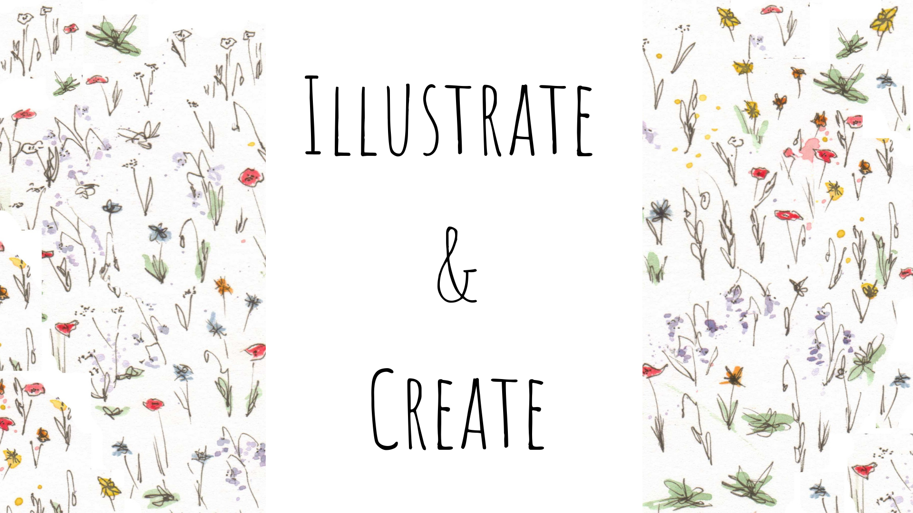

Author & Illustrator collaboration Form
This form has been designed to help me understand your vision for your book & help the illustration process run seamlessly.
Please take your time filling this in, things can be adjusted as the project goes along. The information you provide me with will help me to create a more accurate quote so we can begin working together on your amazing creation!

Question | Answer
What is your timescale for the completion of your book?
What is the title of your book?
What is the full name of the author?
How long is your book? (in pages and words)
What size would you like it to be? (A4? A5? Custom size?)
How many illustrations would you like?
What layout style do you envisage for the book? E.g. one page of text next to one full page of an image? Text layered over the illustration? Small illustrations positioned amongst text?
Would you like full colour or black and white or A mixture of different illustrations?
Which age audience is your book written for?
Would you like me to illustrate and design the cover for you?
Would you like me to edit the layout of the text and illustrations into a book format?
Would you like me to print the book for you?
Describe the personality, appearance and age of each character that will be illustrated in the book (including animals) e.g. Max- 6 years old, mischievous, intelligent, kind, adventurous. Spud (cat) - old, sassy, aggressive
(this is to help inform the facial expressions of each character)
Synopsis of your story (can be attached as a document if easier)

If applicable please send me any photos you have of anything that will help me understand your vision for the book- whether that’s illustrations that you like the style of, photos of landscapes or buildings that feature in your story, characters from films, outfits etc! If you’d prefer me to use my imagination and your manuscript to come up with the pictures then that is perfect but please bear in mind what I imagine might differ to what you do!

Please send this form back to me through email and I will then generate a quote for you!

Speak soon,
Eimear Kew-Morrin

www.illustrateandcreate.net
Illustrate & Create (@illustrate_and_create) • Instagram photos and videos

